Cairo University  
Faculty of Computers and Information



**CS251**

**Software Engineering I**

Project Name

Software Design

Team Names

Month & Year

Contents

Instructions [To be removed] 3

Team 3

Document Purpose and Audience 3

System Models 3

I. System Decomposition 3

II. Class diagrams 6

Important Algorithm 7

III. Sequence diagrams 7

Class - Sequence Usage Table 9

Ownership Report 10

Policy Regarding Plagiarism: 10

References 10

Authors 10

# Team

|  |  |  |  |
| --- | --- | --- | --- |
| **ID** | **Name** | **Email** | **Mobile** |
| 20170002 | Ibrahim Ramadan | ibrahemramadan130@gmail.com | 01152395815 |
| 20170022 | Ahmed Sayed Mansour | ahmed.mans20719@gmail.com | 01117908189 |
| 20170136 | Atef Magdy Metwally | atefmagdy12@gmail.com | 01120797140 |
| 20170257 | Mohamed Mostafa Awad | mmostafaouda@gmail.com | 01122331195 |

# Document Purpose and Audience

This Software Requirements Specification (SRS) provides an overview of the purpose, scope, functional requirements, non-functional requirements and overview of the project.

The aim of this document analyze and give an in-depth insight of the complete API by defining the problem statement in detail.

The audience to read this document client, project manager, system analysis, system designer, developer.

# System Models

## System Decomposition

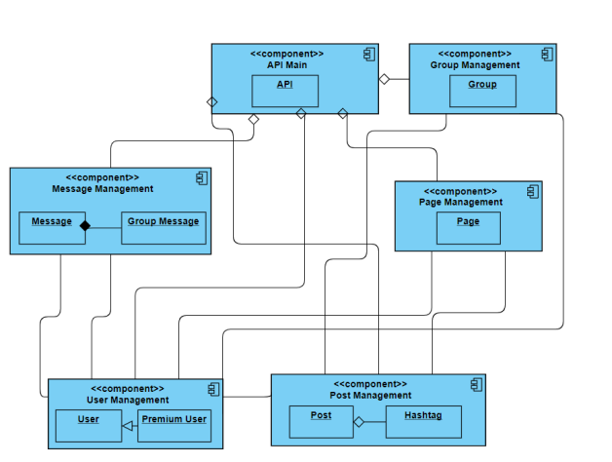

## 

## Class diagrams

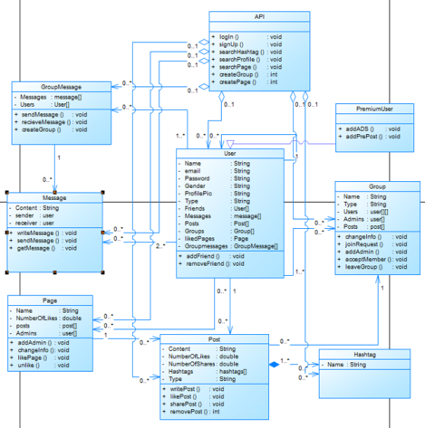

| **Class ID** | **Class Name** | **Subsystem ID** | **Description & Responsibility** |
| --- | --- | --- | --- |
| 1 | API | API main | Organize functions between other classes |
| 2 | Group | Group management | Make functions of Group |
| 3 | Message | Message  management | Make functions of message |
| 4 | Group Message | Message  management | Make functions of group message |
| 5 | Page | page  management | Make functions of page |
| 6 | user | user  management | Make functions of user |
| 7 | Premium user | user  management | Make functions of Premium user |
| 8 | Post | post management | Make functions of post |
| 9 | Hashtag | post management | Make functions of hashtag |

### 

### Important Algorithm

## Sequence diagrams

1. Login

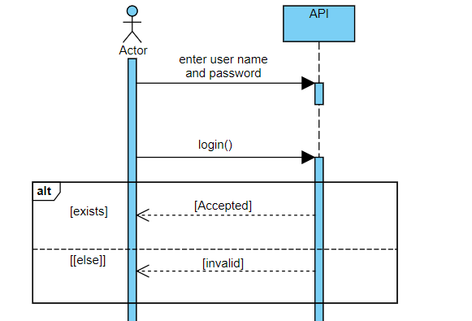

1. Add friend

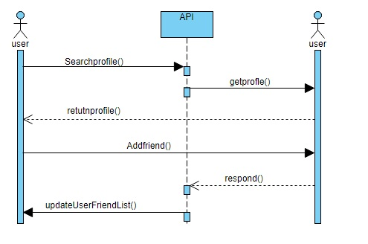

1. Create page

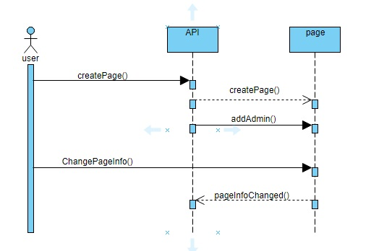

1. Like Page

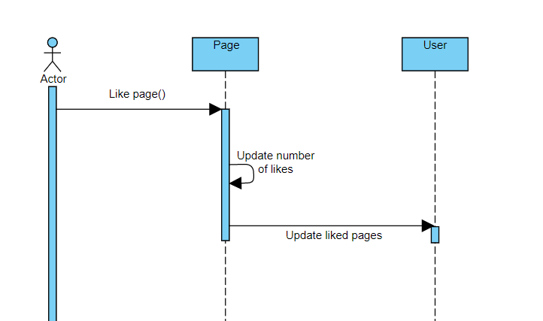

1. Add admin

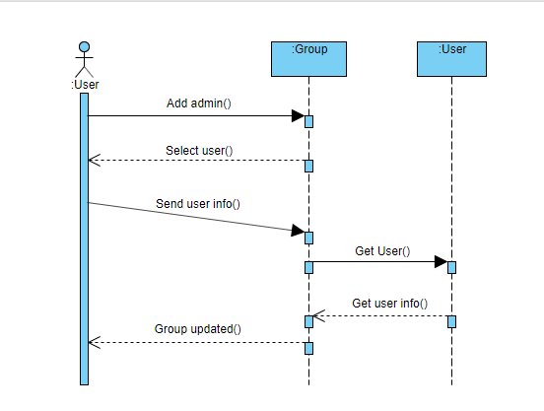

1. Create Group

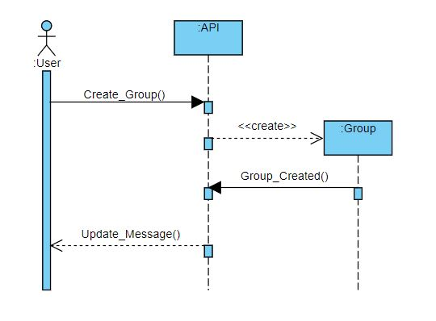

1. Join Group

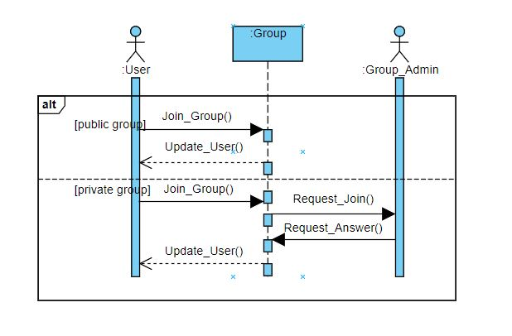

1. Write Post

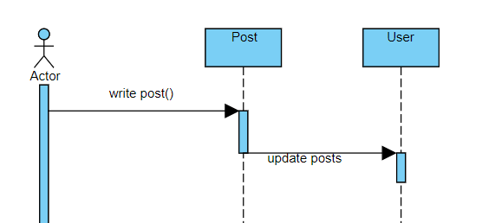

1. Share Post

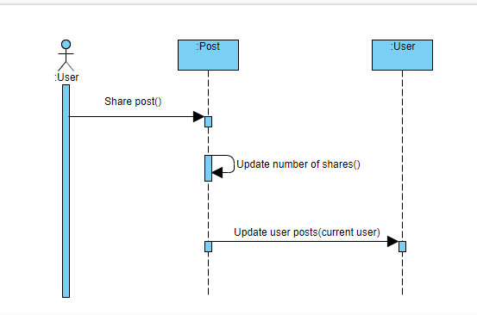

### 

### Class - Sequence Usage Table

| **Class Name** | **Sequence Diagrams** | **Overall used methods** |
| --- | --- | --- |
| API | 1,3,6 | GetData |
| User | 2 | saveData |
| Page | 4,5 | saveData |
| Group | 7 | saveData |
| Post | 8,9 | SaveData |

# Ownership Report

|  |  |
| --- | --- |
| **Item** | **Owners** |
| Sequence Diagram | *Ibrahim Ramadan*  *Atef Magdy*  *Mohamed Mostafa*  *Ahmed Sayed* |
| Component Diagram | *Mohamed Mostafa*  *Ibrahim Ramadan*  *Atef Magdy*  *Ahmed Sayed* |
| Modifying phase1 | *Ibrahim Ramadan*  *Mohamed Mostafa* |

# References

# Authors